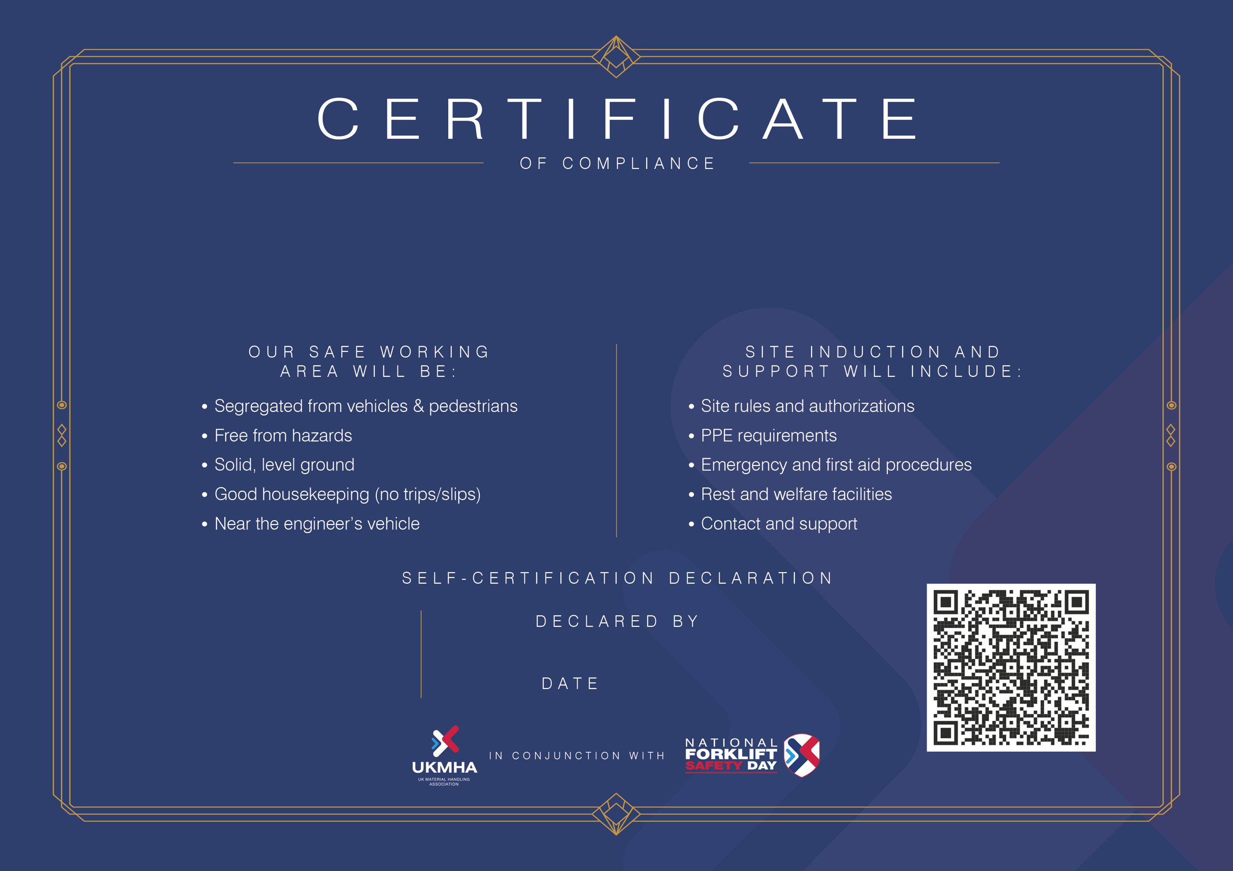
Forename Surname
00.00.00
This certificate records COMPANY NAME HERE’s commitment to
provide a Safe Working Area for visiting engineers in accordance with the
UKMHA Safe Working Area Charter.

